**Registers of 8085 microprocessor**

* Difficulty Level : [Easy](https://www.geeksforgeeks.org/easy/)
* Last Updated : 20 Aug, 2020

A **microprocessor** is a multipurpose, programmable, clock-driven, register-based electronic device that reads binary instructions from a storage device called memory, accepts binary data as input and processes data according to those instructions and provide results as output. A 8085 microprocessor, is a second generation 8-bit microprocessor and is the base for studying and using all the microprocessor available in the market.

**Registers in 8085:**

Attention reader! Don’t stop learning now. Get hold of all the important CS Theory concepts for SDE interviews with the [**CS Theory Course**](https://practice.geeksforgeeks.org/courses/SDE-theory?vC=1) at a student-friendly price and become industry ready.

**(a) General Purpose Registers –**

The 8085 has six general-purpose registers to store 8-bit data; these are identified as- B, C, D, E, H, and L. These can be combined as register pairs – BC, DE, and HL, to perform some 16-bit operation. These registers are used to store or copy temporary data, by using instructions, during the execution of the program.

**(b) Specific Purpose Registers –**

* **Accumulator:**  
  The accumulator is an 8-bit register (can store 8-bit data) that is the part of the arithmetic and logical unit (ALU). After performing arithmetical or logical operations, the result is stored in accumulator. Accumulator is also defined as register A.
* **Flag registers:**

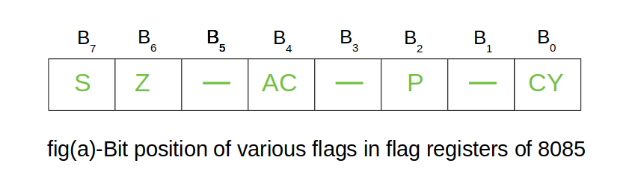

The flag register is a special purpose register and it is completely different from other registers in microprocessor. It consists of 8 bits and only 5 of them are useful. The other three are left vacant and are used in the future Intel versions.These 5 flags are set or reset (when value of flag is 1, then it is said to be set and when value is 0, then it is said to be reset) after an operation according to data condition of the result in the accumulator and other registers. The 5 flag registers are:

* 1. **Sign Flag:** It occupies the seventh bit of the flag register, which is also known as the most significant bit. It helps the programmer to know whether the number stored in the accumulator is positive or negative. If the sign flag is set, it means that number stored in the accumulator is negative, and if reset, then the number is positive.
  2. **Zero Flag:**: It occupies the sixth bit of the flag register. It is set, when the operation performed in the ALU results in zero(all 8 bits are zero), otherwise it is reset. It helps in determining if two numbers are equal or not.
  3. **Auxiliary Carry Flag:** It occupies the fourth bit of the flag register. In an arithmetic operation, when a carry flag is generated by the third bit and passed on to the fourth bit, then Auxiliary Carry flag is set. If not flag is reset. This flag is used internally for BCD(Binary-Coded decimal Number) operations.

**Note –** This is the only flag register in 8085 which is not accessible by user.

* 1. **Parity Flag:** It occupies the second bit of the flag register. This flag tests for number of 1’s in the accumulator. If the accumulator holds even number of 1’s, then this flag is set and it is said to even parity. On the other hand if the number of 1’s is odd, then it is reset and it is said to be odd parity.
  2. **Carry Flag:** It occupies the zeroth bit of the flag register. If the arithmetic operation results in a carry(if result is more than 8 bit), then Carry Flag is set; otherwise it is reset.

**(c) Memory Registers –**

There are two 16-bit registers used to hold memory addresses. The size of these registers is 16 bits because the memory addresses are 16 bits. They are :-

* **Program Counter:** This register is used to sequence the execution of the instructions. The function of the program counter is to point to the memory address from which the next byte is to be fetched. When a byte (machine code) is being fetched, the program counter is incremented by one to point to the next memory location.
* **Stack Pointer:** It is used as a memory pointer. It points to a memory location in read/write memory, called the stack. It is always incremented/decremented by 2 during push and pop operation.

**Example –**  
Here two binary numbers are added. The result produced is stored in the accumulator. Now lets check what each bit means. Refer to the below explanation simultaneously to connect them with the example.

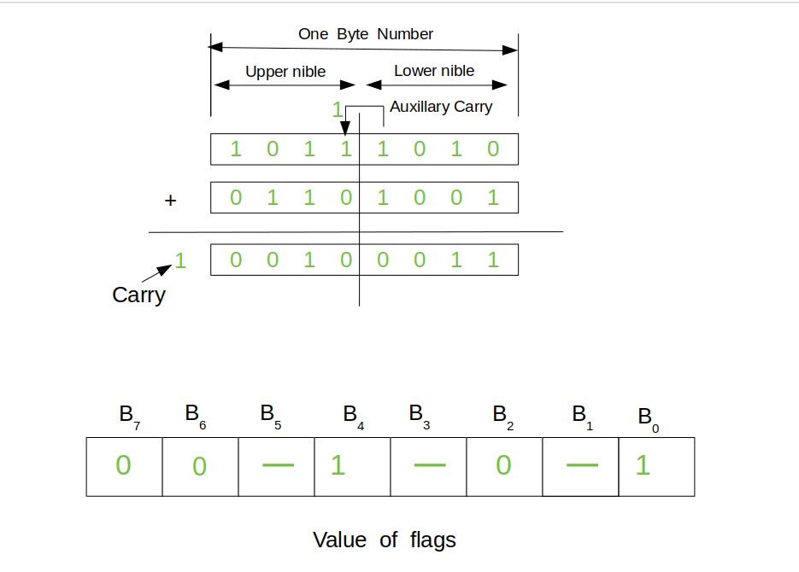

* + **Sign Flag (7th bit):** It is reset(0), which means number stored in the accumulator is positive.
  + **Zero Flag (6th bit):** It is reset(0), thus result of the operations performed in the ALU is non-zero.
  + **Auxiliary Carry Flag (4th bit):** We can see that b3 generates a carry which is taken by b4, thus auxiliary carry flag gets set (1).
  + **Parity Flag (2nd bit):** It is reset(0), it means that parity is odd. The accumulator holds odd number of 1’s.
  + **Carry Flag (0th bit):** It is set(1), output results in more than 8 bit.